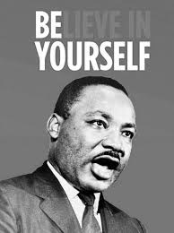
Martin Luther King Jr. Internet Scavenger Hunt

Website #1:
Go to the following site and fill in the following information about Martin Luther King Jr. http://www.cnn.com/2013/01/17/us/martin-luther-king-jr-fast-facts/
Birthdate:______________________ Death Date:__________________________
Birthplace:_____________________ Birth name:___________________________
He was the first African-American to be named magazine's Man of the Year.
According to the King Center, Dr. King's "I Have a Dream" speech is ____ minutes long.
Website #2
Go the following site and watch the video titled “History: Dr. Martin Luther King, Jr. Remembered.” Answer the questions below.
http://video.nationalgeographic.com/video/kids/history-kids/mlk-day-vin-kids/

What was the goal of the Civil Rights Movement? ________________________________________________________________________________
What were Jim Crow Laws? ________________________________________________________________________________
What was the name of the lady that refused to give up her seat on the bus? ________________________________________________________________________________

What famous words did King speak at the base of the Lincoln Memorial? ________________________________________________________________________________

In what year did congress pass the Civil Rights Act? ______________________________________

What award was Martin Luther King Jr. given in 1964? ____________________________________

Website #3
Go to the following site and choose one quote by MLK Jr. and write it below:

http://www.brainyquote.com/quotes/authors/m/martin_luther_king_jr.html

________________________________________________________________________________________________________________________________________________________________

