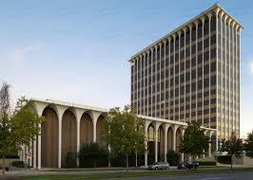
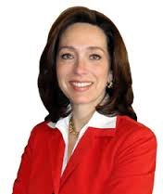
Local Government
Led by:
Mayor
Our Mayor:
Teresa Tomlinson
Works in the Government Center
Responsible for:
Making/makes decisions for the city
Duties include:
Makes promises to make the city better, gives speeches, works with people in the city, makes decision about taxes, and works with the press and city council

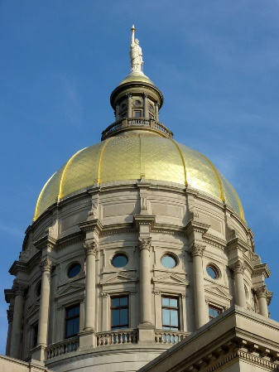
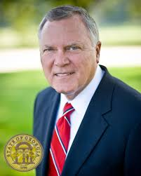
State Government
Led by:
Governor
Our Governor:
Nathan Deal
Works in the Georgia State Capitol Building
(gold dome)
Responsible for:
Making the state a great place for its residents to live
Duties:
Choosing other state leaders, deciding how to spend money for the state, helping the state follow new laws and programs, and searching for ways to make the state better

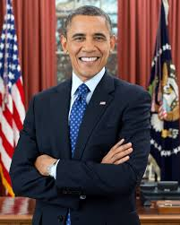
National Government
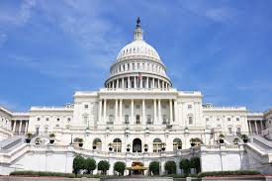
Led by:
President
Our President:
Barack Obama
Works in the White House
And the National Capitol Building (white dome)

Responsibilities:
In charge of making important decisions for our nation (The United States of America)

Duties:

Appoints members of the Cabinet, Supreme Court and leaders of other agencies, to sign legislation from Congress into law or to veto it, enforce and implement the laws set in place by Congress, and working peacefully with other nations

